**Football Playbook**



**OFFENSE**

**Positions**

* C - Center Behind ball, in front of QB
* G - Guard Adjacent to C (two)
* T - Tackle Adjacent to G (two)
* TE - Tight End Adjacent to one T
* SE - Split End Ellig. Receiver designated by being on the line of scrimmage.
* FL - Flanker Designated by being off the (LOS)
* W - Wing Aligned 1yard by 1yard off the TE (1x1)
* S - Slot aligned to split end side
* 3 - Tailback Used in all formations (except Bone and Oneback set)
* 4 - Fullback Used in all formations
* 2 - Halfback Used in Bone, Power I and T formations

**Hole Numbering**

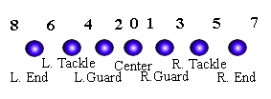

**Play Numbering**

Plays are named for the player running the ball and the hole he's running to.  
EXAMPLE: 42 DIVE means the 4 back (fullback) is running in the 2 hole (Dive)  
(in some even simpler systems, this is dive right)

**Calling Plays**

Plays are generally called using one of two methods:

1. Backfield set, the formation, the play being run.  
2. Formation, backfield set, the play being run.  
EXAMPLE: I PRO RIGHT OPTION LEFT

**Offensive Blocking**

Thanks to Ben Lankford ([lankfob@email.uah.edu](mailto:lankfob@email.uah.edu))

Offensive Blocking The basic run block is the drive block. The offensive lineman buries his head is the opponent's midsection or chest and pushes as hard as he can for as long as he can. The object, of course, is to DRIVE the defensive player as far off the line of scrimmage as possible. Depending on how the defense is taught to react to the offensive and what type of play is being run, the offensive lineman should put his helmet slightly to one side or another on the opponent. In the system I played in, our linemen hit slightly to the play side of the defense, thus placing their bodies between the defense and the ball carrier. The cut block is used to take out a defensive player's legs so that he falls down immediately. This is illegal outside of the interior line of scrimmage due to the nature of the block. The offensive lineman fires out of his stance aiming at the opponent's shins. Since both players are fairly low to the ground and leaning over, the result is usually that the defensive player falls on top of the offensive lineman. The pull block is used to move a lineman from one position to another. It is used most commonly on traps and sweeps. The pulling lineman (usually the guard) turns and runs parallel to the line of scrimmage

to the point where he is to block. He is usually assigned to block the nearest defender to him. This, however, leaves a "hole" where the lineman started out, so the play side linemen must "block down"one man to account for this gap. The double team block is simple. Two offensive players drive block one defender. This is used in situations where the defender is an outstanding player or when the defender absolutely MUST be driven out of the way. Straight-up pass blocking (or pure pass blocking) means that the offensive lineman hits the defender just enough to stall him, and then backs up one step. The defender will charge again, and the process is repeated. So long as the defender never reaches the quarterback, the pass block will be successful. Play-action pass blocking indicates that the offensive line should try to "sell" a particular play to the interior defense. For example, if the defense is playing a strong inside running team, they will expect the ball to come up the middle. When the offensive line fires out like they are about to drive block and the defense sees the QB motioning the ball to the running back, they believe they have a run play called and react accordingly. Then the offensive linemen break off into pure pass blocking, and the defense realizes that the QB only faked a handoff to the running back, who usually runs an interior pass pattern or helps in blocking. By this time, the linemen and linebackers don't have enough time to rush, and the defensive backs who were looking in to the play will have broken in to try to support the run defense. This usually leaves the receivers open. One interesting note about interior line blocking. It is legal to do many things on either the "initial contact" or when within 5 yards laterally or 2 yards forward or back of the spot of the ball. One may clip, block below the waist, push in the back, or do many other maneuvers too dangerous to perform in the open field. Also, since it is assumed that the offensive line will fire out to hit the defense, a lineman may actually go OVER the line of scrimmage when a pass is thrown. Many teams employ "quickie" patterns designed to catch a DB or LB off guard. These passes are usually three step drop patterns breaking inside or outside very quickly. In my old system, the quarterback would actually pick the receiver he was going to throw to before he even called out the snap count. As soon as his third step hit the ground, the ball was in the air. This takes about one second to do, and that is nowhere near enough time for a lineman to block AND get behind the line of scrimmage. Therefore, on quick passes, a lineman may be up to one yard in front of the line of scrimmage. One more rule: when a screen pass is thrown, the linemen must usually be in front of the line of scrimmage. But in order for this to be legal, the receiver (usually a running back) must catch the ball BEHIND the line of scrimmage.

**Running plays**

Running plays are designated... There are usually two numbers followed by a one word description. The first number is either the number of a particular back (eg 2 for halfback, 3 for fullback, etc.), or it is a series of running plays (30's for traps, 40's for power plays, 50's for counters, 60's for sweeps etc.). The second number designates the location of the play. Generally, the even numbers are to the right, odds to the left, and the higher the number the further outside it is. That is not to say that odds are always to the left or that outside plays could not use the lowest numbers. It depends on the coach. The play description is usually where the offensive linemen know their assignments. For example, on "68 sweep", the onside guard knows that he pulls and kicks out the first man outside of the end, the offside guard knows that he pulls and seals off anything trying to cross his face in pursuit of the play. This is one of the classic football plays- the Lombardi sweep. The numbering system can be modified to suit any coach, but it is the easiest thing to use and understand because of its uniformity and simplicity.

It doesn't really matter what you call them, it's just a system 80's could be traps and 10's could be counters, and so on. I've seen 10's as draw plays and 20's as base one-back runs. In the system that I use, 60's, 70's, 80's, and 90's are used for the passing game. 100's are also passes. Here's how I do it... Running Game: 10's- QB 20's- One back 30's- Traps 40's- Power and Sweeps 50's- Counters Passing Game: 60's- QB 5-7 step drop; RB and FB have routes. 70's- QB 5-7 step drop; RB blocks, FB has route. 80's- QB 5-7 step drop; RB has route, FB blocks. 90's- QB 5-7 step drop; RB and FB block. 100's- QB 3 step drop; RB and FB block. Whether it's a five or seven step drop depends on the play and that's a coaching point with the QB. Another coaching point is between the 90 series and the 100 series. In the 90's, the offensive line protects big on big (linemen vs. linemen) and the backs pickup anyone else. In the 100's "fire" protection is used; the OL blocks man on or over him, and the backs block the anything coming from the end of the line. For draw plays, I use the passing numbers because the play must look like a pass. eg- an "80 draw" call would be a draw to the RB with the FB lead blocking.

**OFFENSIVE FORMATIONS**

**Backfield Sets**

Split - Backs set to either side of the QB  
I - Backs stacked behind QB  
Power I - Same as I but with Halfback beside the Fullback  
Strong - Fullback behind QB Tailback to TE side, beside the FB  
Weak - Fullback behind QB Tailback to SE side, beside the FB  
T - Fullback behind QB Halfbacks set on either side, even w/FB  
Bone - Fullback behind QB Halfbacks set to either side, behind FB  
Breaking - Bone formation with a missing back in the bone   
Shotgun - QB back 1 yard off [LOS](http://library.thinkquest.org/12590/dictionary.htm#Line of Scrimmage:)  
Fullhouse - Any formation where all backs in backfield  
One-Back - One running back in the backfield  
Empty - No backs (4 receivers)

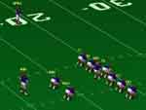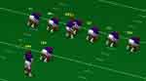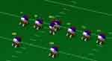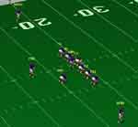

Power I-Formation I-Formation Split Backs Formation Strong Formation

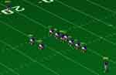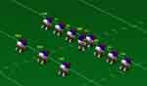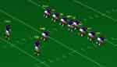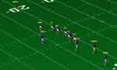

Weak Formation T-Formation Bone Formation Shot Gun Formation

**Formations**

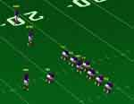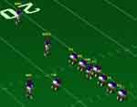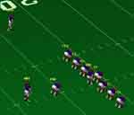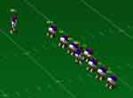

Slot Formation Tight Slot Formation Flanker Formation Wing Formation

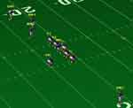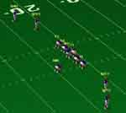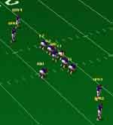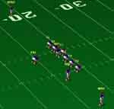

Trips Formation Spread Formation Spread End-over Form. Single Wing Formation

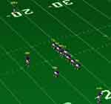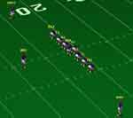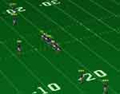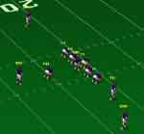

Deuce Formation Ace Formation Mirror Formation Flex Formation

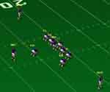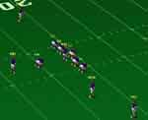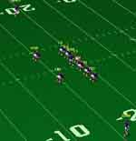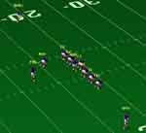

Spread Slot Formation Open Formation Right Formation Opposite Formation

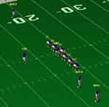

Strong Formation Wide Formation

**DEFENSE**

All defensive formations labeled with two numbers and strength. Modifiers added to describe variants and pass coverage.

**Positions**

* N - Nose Guard - In an Odd front - plays between O-guards
* T - Tackle - somewhere between O-guards and O-Tackle
* E - can line up anywhere from inside of O-Tackle to outside of TE
* LB - Linebacker - usually within 5 yards of LOS, 2 Yards of TE. Often classified as Inside/Outside or Strong/Weak ("Sam"/"Willie")
* FS - Safety -Defensive Back - Free Safety plays ~12 yards away from LOS
* SS- Strong Safety plays to Offensive Strong Side, and could sometimes be easily confused as a Linebacker
* CB - Corner back - Defensive back - plays in front of WR, or if there is no wide out, could scoot back and in the ball to the outside.

The main ambiguity is a matter of telling the difference between an outside Linebacker on or near the line of scrimmage and a lineman. For pro-football, I would say that the default convention is just to If you really wanted to analyze these Ends, you have to look at what the guy does, if he rushes the passer and/or hits the Tackle/TightEnd every play you could call him a defensive end. If you see him drop into a zone when he's on the weak side, then call him a linebacker. But its really going to be more of a matter of what he does over a series of plays then how he lines up and what he does on any one play.

If you really wanted to analyze these Ends, you have to look at what the guy does, if he rushes the passer and/or hits the Tackle/TightEnd every play you could call him a defensive end. If you see him drop into a zone when he's on the weak side, then call him a linebacker. But its really going to be more of a matter of what he does over a series of plays then how he lines up and what he does on any one play.

**Calling Plays**

1. Formation, pass coverage, Blitzing/stunting or  
2. Formation into Formation, pass coverage, blitzing/stunting  
(when they line up in one formation then change to another)

Example : 5-2 Left Eagle Man = There are 5 Defensive Lineman, 2 Linebackers, (which implies 4 DB's). The defense seems to think that the strong side is to the left. (this would be inferred either from the location of the strong safety and/or which individual linebacker lined up on which side and/or just a simple count along the "y-axis"). The "Eagle" means that (if I remember correctly) the Nosegaurd is lined up at an angle, ready to punish the center (as opposed to lining up right in front of the center, and perpendicular to the LOS). And somehow, you have determined that the coverage is man on man.

**DEFENSIVE FORMATIONS**

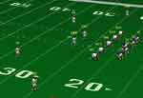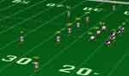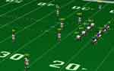

5-2 Defensive Formation 3-4 Defensive Formation 4-3 Defensive Formation

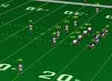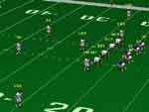

4-4 Defensive Formation 6-1 Defensive Formation

**Blitzes**

To describe a Blitz, you name the Linebacker and tell what kind of blitz or "stunt" he does.

Left&right - Weak&Strong : I'm not sure what your best choice is here. Almost every kind of defensive "direction" can either be described on a "relative axis" weak and strong or an "absolute axis" left or right. They are completely interchangeable with being able to describe what’s happening. But If you want to spot patterns, you might want to describe every play both ways!

You can name a particular type of blitz with another relative-direction convention- inside or outside hole. (inside = closer to center).

Example blitz naming conventions:

4-4 - In a 4-4 call the weak-outside-linebacker "Willie" and the Strong outside Linebacker "Sam". Its less common to move around the inside backers so I'll call the Right inside Backer "Ringo", and the Left inside Backer "Louie".

5-2 - Either "Ringo" & "Louie", if they always line up on the same side, or "Willie" and "Sam" if the linebackers changes sides according to the strength of Offense.

4-3, 6-1, 5-3 - Outside guys can still be either W&S or R&L ... lets call the middle linebacker .... ohh .. "Mickey".

When a linebacker blitzes, he basically picks a hole and runs through it. Its his responsibility to make sure nothing comes through that hole. And after he gets through he either

(a) is supposed to pursue from the inside,  
(b) pursue from the outside [i.e. keep outside contain] or if he's lucky  
(c) just raise hell however he can.

Often, if a linebacker goes through a hole, the D-line man who's hole that is, is assigned to penetrate his other hole.

Example Absolute-Blitz Naming : Willie Blast Left (4-4) Willie is going to take the Left hole, so the end will take the right hole. (and remember that's left and right from the defensive perspective) I don't think what you name the actual blitz patterns is that important.

We'll define a set for you here:

Blast - either left or right hole, or strong or weak hole.  
Shoot - Inside hole  
Fire - Outside Hole  
Example # 1: "4-4 willie blast left" OR "4-4 Willie Shoot" or "4-4 Shoot the willie"

Example #2

If a linebacker goes to a hole that he doesn't line up in front of, you have to make up more names (these name are less macho sounding for some reason - "loop" or "swing" - loop = 2 holes to the weak side and swing = 2 holes to the strong side).

"4-4 Fire Ringo Loop Sam" or "4-4 Fire the Ringo, Loop the Sam"

Stunts that Defensive Lineman do with out Linebackers: "Twist" - One lineman goes in and the other goes out. Who ever is going in goes first. for 4-fronts : twist left/right or twist strong/weak is really all there is. For odd fronts, either the NoseGaurd and Tackle go, or the end and a tackle go -so you've got "Tackle Twist", and "Twist" L/R or S/W.

**Pass Coverage**

man-on-man  
zone  
combinations

Defense often intentionally trying to confuse QB. Usually the labeling convention here, is just "Cover 1" or "Cover 2". Each different kind of coverage means some people are man-on-man and some people are zone

If nobody moves in reaction to a man-in-motion then you have a "hint" that there is no Man-on-man defense, and you have definite information that at least one specific player is either just not covered at all, or is supposed to get taken care of in a zone. How strong this hint is, depends on which guy goes in motion.

The first thing the D does is determine pass or run. Here is a sample of what they might do if they read Pass, and the QB is either dropping back, or rolling strong. (strong right for the O).

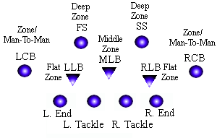

If the Ends are "real" ends, they will rush the passer. If they are outside linebackers, then one or both might still rush the passer, but they could also take the Flat, and allow the linebackers to do other stuff.

The defense usually assigns gaps as letters.

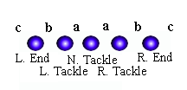

A stunt in the a gap would usually be called a gut. Why I really don't know. A b gap stunt is called a blast, a c gap is called crush and a d gap stunt is called a dog. A defense will usually put a defensive lineman down into the gap and they will slant away and try to take the offensive line with him and therefore leaving a gap for the stunting linebacker. A force is a stunt in where the outside linebacker or the strong safety stunts to the outside and the defensive end goes inside. A fire is where the strong safety or the outside linebacker goes inside while the defensive end works his way outside.